Name: _____________________________________

Date: ______________________________________

Book Project # 1: Children’s Book

Step # 1: Pick a childhood book that you enjoyed reading or having read to you.
Examples: The Cat in the Hat
Five Monkeys Jumping on the Bed
The Saggy Baggy Elephant

Step # 2: Reread the book to become familiar with it again

Step # 3: Design a book cover
It must have picture(s) related to the topic of the book
You may not use the cover design that the book already has
You must create your own picture
You must have the name of the book, author, and illustrator
The cover must be in color

Step # 4: Do a simple book report & a plot diagram of the book
Climax
High Point
The Simple Book report must include the following:
Title, author, illustrator
Longest word, most difficult word
Summary of the story
Favorite part of the story
Falling Action
Rising Action
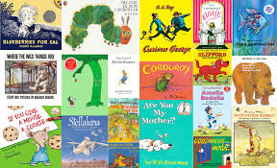
Resolution,
Conclusion
Exposition, Introduction
I
Timeline for Project

Sept. 9: told about project, given handouts
Sept. 19: must have a book picked out & shown to Mrs. Cassill
Students should be working on the project at home
Oct. 3:Mrs. Cassill will go over a plot diagram & how to do one
Students will have time in class to draw their cover
Oct. 10: If needed student will be given time to work on in class
Students should be practicing their presentation at home, so they feel comfortable with the book and what they want to say

Oct. 14: Students will do presentations

Grade period ends Oct. 17

