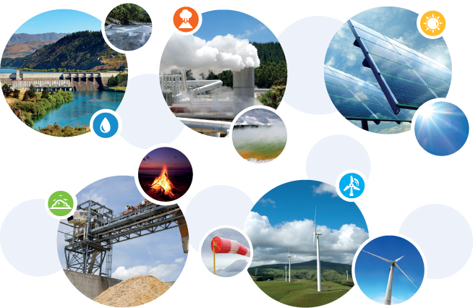
Name: _________________________
Date: __________________________
Energy Sources Project

Step 1: Students are to take a picture of an energy source such as: solar panels, wind turbine, natural gas well or pump. Use your book for examples.
Step 2: Print it or email it to Mrs. Cassill. If you can’t take a picture, please have your parent / guardian write a note.
Step 3: Answer questions related to picture.

Q # 1: What type of energy source is this? ____________________
_____________________________________________________
_____________________________________________________

Q # 2: When and where did you take this picture? _______________
_____________________________________________________
_____________________________________________________
_____________________________________________________

Q # 3: Why would this energy source be used at the location you took the picture? ______________________________________________
_____________________________________________________
_____________________________________________________
_____________________________________________________
_____________________________________________________

Q # 4: What are two facts about this type of energy source? ______
_____________________________________________________
_____________________________________________________
_____________________________________________________

Q # 5: What are two pros and two cons about this energy source? Use your book.
_____________________________________________________
_____________________________________________________
_____________________________________________________
_____________________________________________________
_____________________________________________________
_____________________________________________________
_____________________________________________________

